
COVERING LONDON & THE HOME COUNTIES
Jack Hunt School Refurbishment
Flat roof replacement

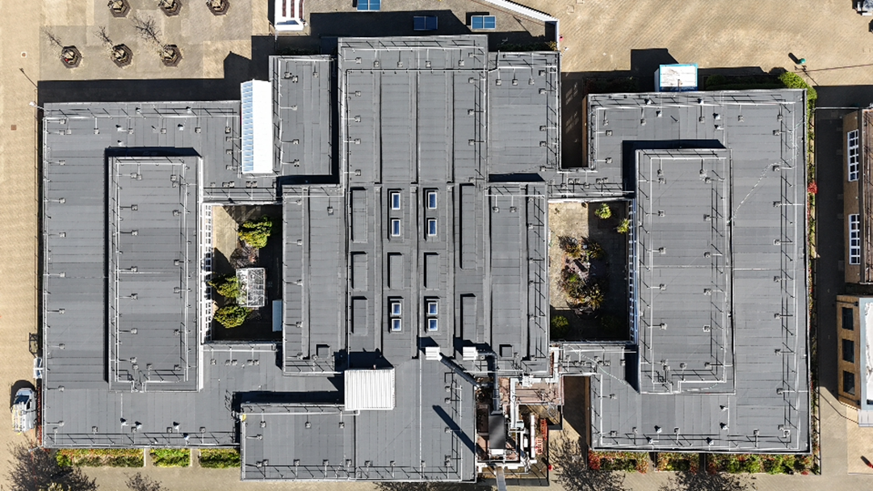
Contract Value: £1.1 million
Contract Dates: Jul 2024 – Feb 2025
Positive feedback from both the school leadership team and the local authority praised the professionalism and flexibility of the site staff, excellent communication throughout the works, and the minimal disruption caused despite the project's complexity.
Description:
This project highlights our ability to manage complex, occupied sites, delivering successful outcomes within a live secondary school and public-access swimming pool. With over 2,000 daily users, it required careful phasing, strong safeguarding, and close stakeholder coordination. To minimise disruption during construction, nearly 40% of noisy or high-risk work was scheduled during school holidays or weekends. Work areas were zoned to separate construction from daily school activities, while critical internal tasks were completed outside school hours. Daily coordination with school staff ensured the programme aligned with timetables, exams, and events.

Scope of Works:
- Full felt roof replacement of over 3000m² using a Bauder system with designed tapered insulation
- Replacement of high-level windows and rooflights
- Internal drainage upgrades
- Design, supply, and installation of a new glazed entrance atrium

Key Challenges & Lessons Learned:
Occupied premises: Working within a live environment posed significant challenges, as the site remained fully operational throughout the project. This required careful planning to ensure the safety of students, staff, and the public, while maintaining uninterrupted access to school facilities and community amenities. Construction activities had to be meticulously phased and scheduled around the school timetable, exams, and events, with enhanced safeguarding measures and constant communication with stakeholders to minimise disruption and maintain a secure, functional environment.
Tight programme: The project was delivered under a highly compressed timeline, requiring efficient planning, rapid decision-making, and close coordination across all teams. With limited flexibility for delays, works had to be carefully sequenced and resourced to maintain momentum and meet critical milestones.
Programme Success:
The project was delivered on time, within budget, and with zero reportable incidents. Through proactive communication, flexible scheduling, and a strong focus on health and safety, the team ensured minimal disruption to the school and community users.

