
COVERING LONDON & THE HOME COUNTIES
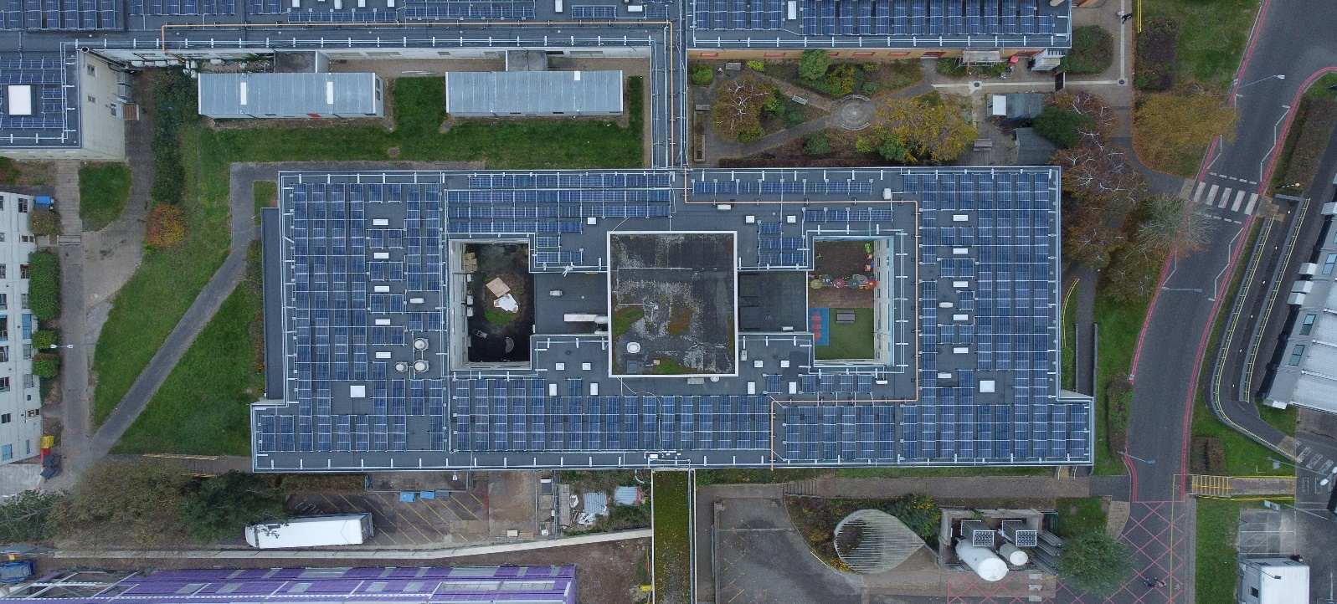
Value: £5.3 million
Contract Dates: Phased delivery (2021–2024)
Milton Keynes University Hospital (MKUH)
Solar and Roofing Infrastructure Upgrade

Key Challenges & Lessons Learned:
Live clinical environment: Construction zones were often adjacent to or above critical care departments and staff corridors, requiring meticulous planning to maintain safe access and uninterrupted services. A carefully phased delivery strategy was developed in collaboration with hospital departments, including out-of-hours work and temporary M&E systems to ensure continuity. Dust, noise, and vibration were controlled using acoustic barriers and sealed enclosures, while segregated work zones with controlled access points safeguarded patients and staff.
Stakeholder engagement: Weekly meetings with hospital managers and clinical leads, monthly stakeholder reviews, and daily briefings for facilities and security staff ensured alignment and responsiveness. Real-time updates were shared via signage and noticeboards, and permit-to-work systems were coordinated with hospital engineers for high-risk areas.
Programme Success:
The project was completed on time and within budget, with no critical service disruptions. The installation of over 3,300 solar panels has already generated measurable energy savings, with nearly £50,000 saved on energy bills to date. The upgraded roofing and insulation systems have significantly improved indoor climate conditions, enhancing comfort for patients and staff.
Description:
The Milton Keynes University Hospital (MKUH) Solar and Roofing Infrastructure Upgrade was a £5.3 million project delivered over a 36-month phased programme from 2021 to 2024. Commissioned by the Milton Keynes University Hospital NHS Foundation Trust, the project aimed to enhance the hospital’s energy efficiency and reduce its long-term carbon footprint. All works were carried out while the hospital remained fully operational, serving over 500,000 patient interactions annually across inpatient, outpatient, emergency, and administrative services.

Scope of Works:
- Installation of a new 7500m² Langley flat roofing system
- Upgrading tapered insulation across multiple aging hospital wings
- Fitting over 3,300 photovoltaic solar panels
- Integrated mechanical and electrical (M&E) upgrades across live hospital buildings

“Since the panels went live, we’ve saved nearly £50,000 on energy bills — a figure that will only grow as we complete the next phase. The new roofing has transformed previously outdated areas into more comfortable environments for patients and staff alike.”

